Algorithm for file updates in Python

Project description
This is a test, to remove ip addresses in an allow list, that are under a remove list.

Open the file that contains the allow list
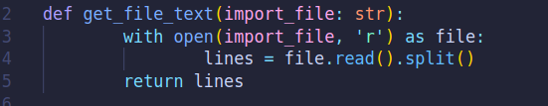
I created this function, that gets the name of the file that is to be read, and reads it, and also splits it into a list. Returns it
I call this for the allow list, and the remove list

Iterate through the remove list
Using list comprehension , the whitelist is going to be equal to everything in the whitelist, but if the item is in the blacklist, then it will ignore it.

Update the file with the revised list of IP addresses
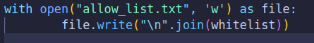
Rewrite the whole file (should not be done in the real world), and combine the lists into a string, using \n, to separate the items.

Summary
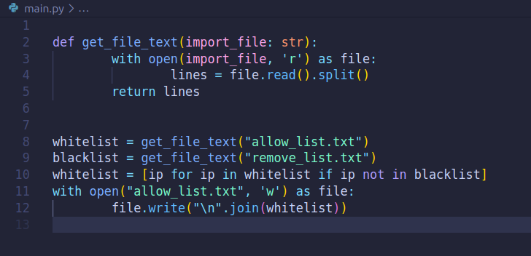
Created a function to read and split the file, and split it into a list. This is done for the allow list and the remove list.
Using list comprehension, the whitelist has the items in the blacklist taken out of it.
Then it is written to the file.

Also this code sucks because I never closed the files, just caused a data leak. Which this fixes, which is the same thing, but I removed the function so I can close the file.
